PTSA REFLECTIONS
The PTSA Reflections theme for the 2017-2018 School year is: WITHIN REACH. Entries are due on Tuesday, 31st October. There are six categories to choose from:
- Dance Choreography  - Film Production  - Literature  - Music Composition  - Photography  - Visual Arts | 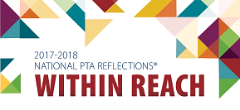
- All submission will be due on Tuesday, 31st October.
- Please refer to the general guidelines and specific rules using the link below as these must be followed. Full program details can be found on WA State PTA Reflections page.
- To submit an entry, please use this Student Entry Form or pick one up in the BLMS office.
- For any questions contact Tanu Varshney tanu.mtr@gmail.com

